[**ME5402/EE5106**](https://ivle.nus.edu.sg/module/student/?CourseID=fbbb2719-731b-415c-bc4f-fc4c208215a9&ClickFrom=Outline)**https://ivle.nus.edu.sg/images/ws_blank.gif ADVANCED ROBOTICS**

Part II: Dynamics and Control

**Mini Project I**

**Instructions:**

1. Put your name and matriculation number on the cover page, and submit the hardcopy of your answer to Prof. Shuzhi Sam Ge (Room E4-05-28) or to my mail box in the ECE general office, by **12 April, 2021**. Submit the original codes of the simulation via IVLE with the file name as your registration number.

Example: If your registration number is HT093376M then the file names must be HT093376M.rar.

1. Two students (OR three students at most) work in group to complete the project. While the work is group and encourage collaboration, each student must have his/her own individual contribution and effort and should be clearly stated in his/her **individual report**. Identical reports will be subject to penalty and or disciplinary actions of the university.
2. Please submit the Groupings to me next Monday.

**Background:**

Recently, robots aided with artificial intelligence have attracted considerable attention in numerous scientific and engineering areas. Different types of robots have been designed and applied in industrial automation for painting, welding, assembly, ironing, and palletizing. Among these robots, the autonomous robot is the typical one, which processes five degrees of freedom (DOFs) and works in a 3-D space. Because of its significant characteristic, the autonomous robot has been widely investigated and utilized to conduct cyclic and boring work.

In general, the study of robots can be divided into two parts: robot kinematics and robot dynamics. The former, which includes the forward kinematics and inverse kinematics, deals with the relationship between the joint variable space and the end-effector position and orientation. The latter, which is closely related to robot controller design, deals with the relationship between the robot motion and the forces/torques.

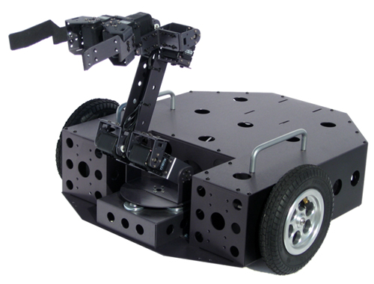

**Figure 1: The autonomous robot in Social Robotics Lab, NUS**

**Scenario:**

In this project, we consider the modeling and control of the autonomous robot, as shown in Figure 1. The geometry of the three wheel robot is presented in Figure 2. The structure and geometry of robot arm is presented in Figure 3. The autonomous robot can be programmed to move a tool, and communicate with other machines using electrical signals. It is a robot composed of three wheel robot and robot arm.

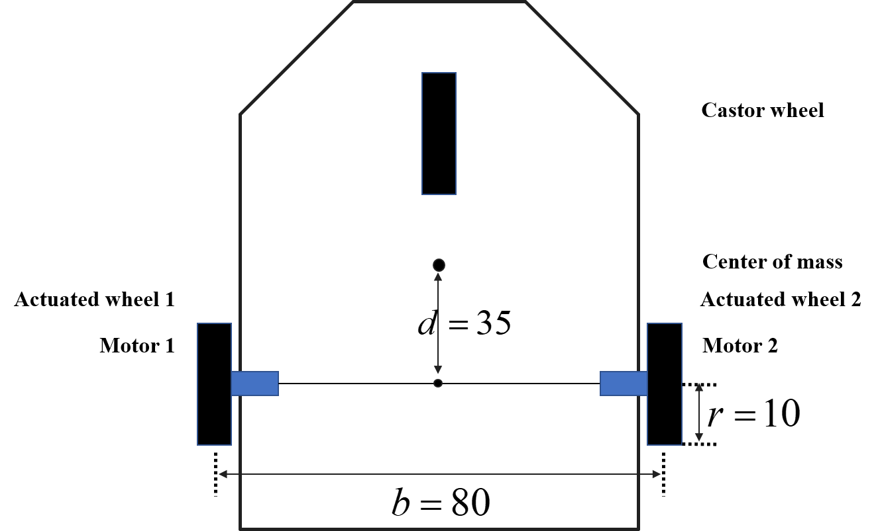

**Figure 2: The geometry of the three wheel robot**

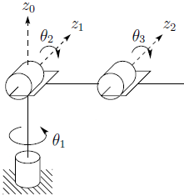 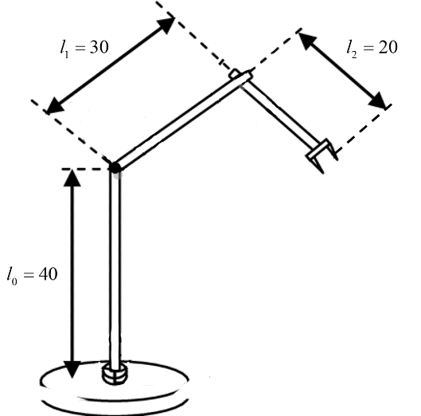

**Figure 3: Structure and geometry of robot arm**

Note:

1. You are free to present your work in any environment, such as C++, python and ADAMS, of your choice.
2. You are free to make any assumptions needed, but with proper explanation.

**List of Projects:**

For the autonomous robot depicted in Figures 2 and 3, please accomplish the following tasks (each group member choose one sub project):

**Project 2-1: Modeling and Animation of the Autonomous Robot**

1. Do literature review on autonomous robot design and virtual robot simulation.
2. Develop the D-H model of the three wheel robot and robot arm in Figures 2 and 3, and derive the Lagrange-Euler equations.
3. Design a CAD model for autonomous robot and his working circumstances using any software or tools of your preference such as Utility 3D, Solid works, etc, use the kinematic and dynamic equation to guide your design.
4. Design a simple control to make the three wheel robot and robot arm to achieve simple tasks such as trajectory following, tracking control, interaction with human and etc.
5. Optional: Discuss the design considerations to ensure a smooth and safe operation of industrial robots. Please clarify the ideas with necessary visual aids. List the problems that you identified, and you are encouraged to propose any new or novel methods to solve them.

**Project 2-2: Interaction Control of the Autonomous Robot**

1. Do literature search on interaction control of the Autonomous Robot.
2. Develop the D-H model of the three wheel robot and robot arm in Figures 2 and 3, and derive the Lagrange-Euler equations.
3. Design impedance control for the robotic arm and discuss the effect of different selection of impedance parameters on the interaction performance.
4. Design Hybrid Force/ Position Control for the autonomous robot.
5. Do a simulation study to demonstrate the interaction control performance of the Autonomous Robot using any software or tools of your preference, such as MATLAB, MRDS, Visual Studio, ADAMS, SolidWorks, etc.
6. Optional: The autonomous robot is supposed to perform handshaking with humans for guest reception, please formulate and model the problem of the robotic handshaking and choose proper interaction control methods as solutions. Discuss the results and limitation.

**Project 2-3: Optimal Interaction Control of the Robotic Arm**

1. Do literature search on optimal interaction control of the Autonomous Robot.
2. Develop the D-H model of the Autonomous Robot in Figures 2 and 3, and derive the Lagrange-Euler equations.
3. Design optimal impedance control for the robotic arm interacting with human arms or environment. Different cost functions considering the trajectory tracking error, energy cost as well as the interaction performance can be chosen. Moreover, the weighting matrices in the cost function can also be specified according to your rational considerations.
4. Do a simulation study to demonstrate the interaction control performance of the autonomous robot using any software or tools of your preference, such as MATLAB, MRDS, Visual Studio, ADAMS, SolidWorks, etc.
5. Optional: The autonomous robot is supposed to perform optimal interactions with human arms or various environments having unknown dynamic parameters and trajectories/shapes in practical applications. Please formulate and model the interaction problem and choose proper optimal control methods as solutions. Discuss the results and limitation.

**Project 2-4: Constrained Control of the Autonomous Robot**

1. Do literature review on the constrained tracking control of the autonomous robot.
2. Derive the Lagrange-Euler equations for the autonomous robot and design a PD or PID control to guarantee each part in Figures 2 and 3 tracks any given desired trajectory.
3. Design constrained control to make each joint of the robotic arm track any given desired trajectory with limited tracking error. (Hint: you may refer to [1-4] for one of the possible controls. You are encouraged to develop the control with other methods with necessary theoretical verification.)
4. Do a simulation study to demonstrate the constrained and PD/PID control performance of the autonomous robot using any software or tools of your preference, such as MATLAB, MRDS, Visual Studio, ADAMS, SolidWorks, etc and compare the results.
5. Optional: Design of adaptive neural network control for the autonomous robot to handle uncertain parameters in the dynamics. Use simulation to demonstrate the performance. (Hint: you may refer to [4].)

**Reference**

1. B. Siciliano, L. Sciavicco, L. Villani, and G. Oriolo, Robotics: Modelling, Planning and Control, Springer Verlag, London, 2009.
2. W. Khalil and E. Dombre, Modeling, Identification and Control of Robots, Elsevier, 2004.
3. L. Sciavicco, and B. Siciliano, Modeling and Control of Robot Manipulators, 2nd Edition, Springer Verlag, London, 2000.
4. S. S. Ge, T. H. Lee and C. J. Harris, [Adaptive Neural Network Control of Robotic Manipulators](http://www.worldscientific.com/books/engineering/3774.html), World Scientific, London, 1998.